Interface Documentation
Internal communication management system.

Department of computer science, university of Jaffna.
- Login page
4).
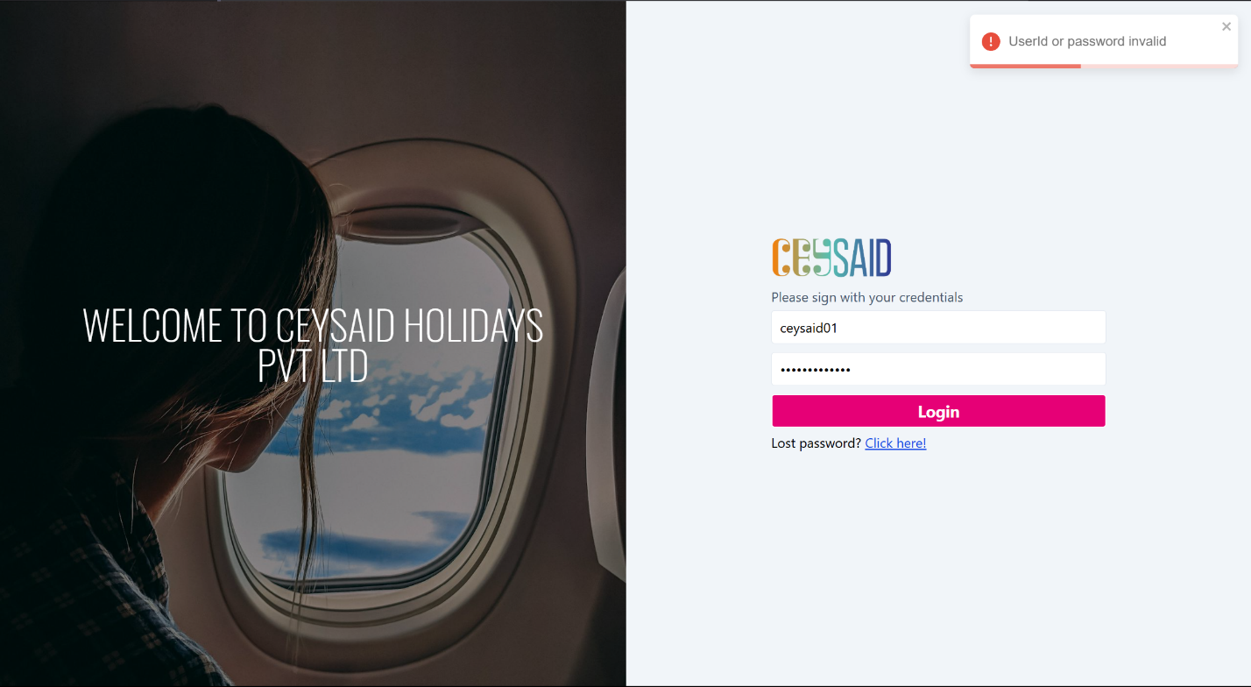
3)
2).
1).

- User Id Input field:
  - Users must enter their unique user ID to log in. (ex: ceysaid01)
- Password Input field:
  - Users must enter their password securely.
  - The password field hides input characters for security.
- Login button:
  - When click the button login.
- Error showing:
  - Types of errors:
    - Username or password incorrect.
    - Login successful.
    - Another server error.

